1. This is the “home screen” of the URL live.goalprofits.com (a log in can be provided).
   * The “scrape” is ONLY required when the figure in box 1 is “HT”.
   * So in the below screenshot, only the data for Concord v Dartford is required.
   * The scrape only needs to be done once, whilst the box 1 figure is “HT”. It will stay at “HT” for approx. 20 minutes but should be scraped as soon as it appears.
   * The numbers in box 1 are minutes showing how long a match has been played. They will go from 1, 2, 3 etc up to 45, then “HT”.
   * Required scrapes are shown in boxes 2, 3, 4, 5, 6 and 7. A further scrape is required by pressing the “i” button. See steps 2 to 5 below.

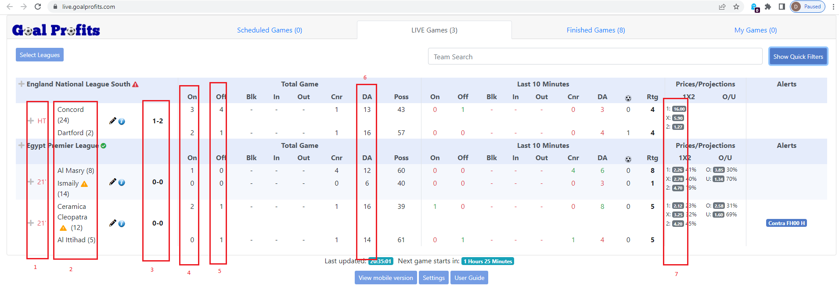

* The scraped data will go into Access. Therefore, as an example, the top game Concord v Dartford in the above screenshot is “HT” in Box 1 so should be scraped.
* Access should have 14 columns as follows.

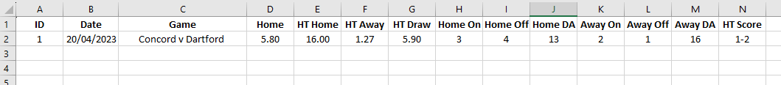

**The above is presented in Excel as an example but should be scraped into Access.**

Column A – ID – this can just be a cumulative count from the scraping program, increasing in order e.g., 1,2,3,4 etc.

Column B – Date – this should be today’s date, in either UK or US format.

Column C – Game – this comes from Box 2 above. The number in brackets next to the team name can be ignored. The two team names should be presented in a single Access cell with a “v” in between the names. The other examples above would be presented as Al Masry v Ismaily and Ceramica Cleopatra v Al Ittihad.

Column D – Home – see step **2 to 5 below** on how to find this figure.

Column E – HT Home – see box 7 above, the figure required is next to the “1:” e.g., “1: 16.00” in the above example. The required scrape is just the 16.00.

Column F – HT Away – see box 7 above, the figure required is next to the “2:” e.g., “2: 1.27” in the above example. The required scrape is just the 1.27.

Column G – HT Draw – see box 7 above, the figure required is next to the “X:” e.g., “X: 5.90” in the example above. The required scrape is just the 5.90.

Column H – Home On – see box 4 above, it is the top figure in the “On” column.

Column I – Home Off – see box 5 above, it is the top figure in the “Off” column.

Column J – Home DA – see box 6 above, it is the top figure in the “DA” column.

Column K – Away On – see box 4 above, it us the bottom figure in the “On” column.

Column L – Away Off - see box 5 above, it is the bottom figure in the “Off” column.

Column M – Away DA - see box 6 above, it is the bottom figure in the “DA” column.

Column N – HT Score – see box 3 above.

1. The final part of the required scrape is within the “i” button (see below).

1. Once the “i” button is clicked, the below screen is displayed, however a further click is required. See #4 below.

1. Once “Pre-Game” is clicked, see #5 below for required scrape.

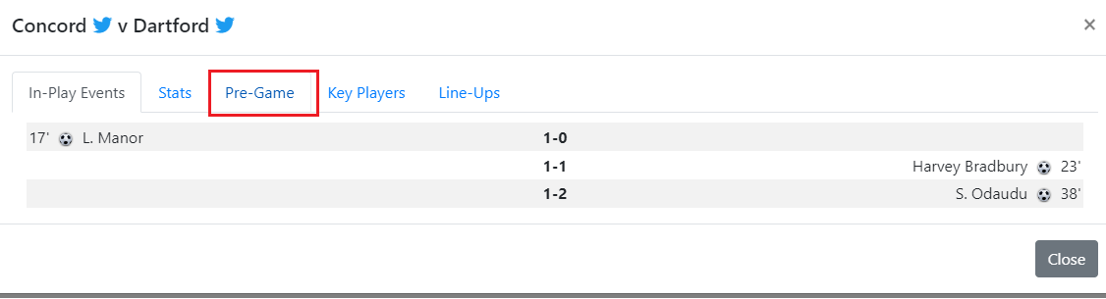

1. Within the “Pre-Game” tab, the box below displays the required data to be scraped.

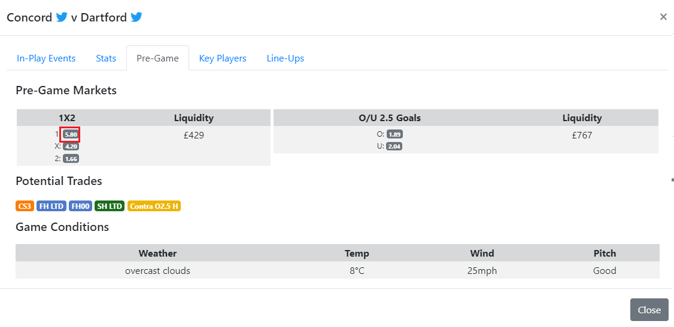  
**Other Notes**

* Sometimes (rarely) the website will crash with a URL error. If Python can detect this, a refresh of the page would be useful.
* If the application freezes, it should reboot and automatically log in and go to the “Live” tab for scraping. Application **must** run 24/7 without error.